0. Introduction V. 3.5
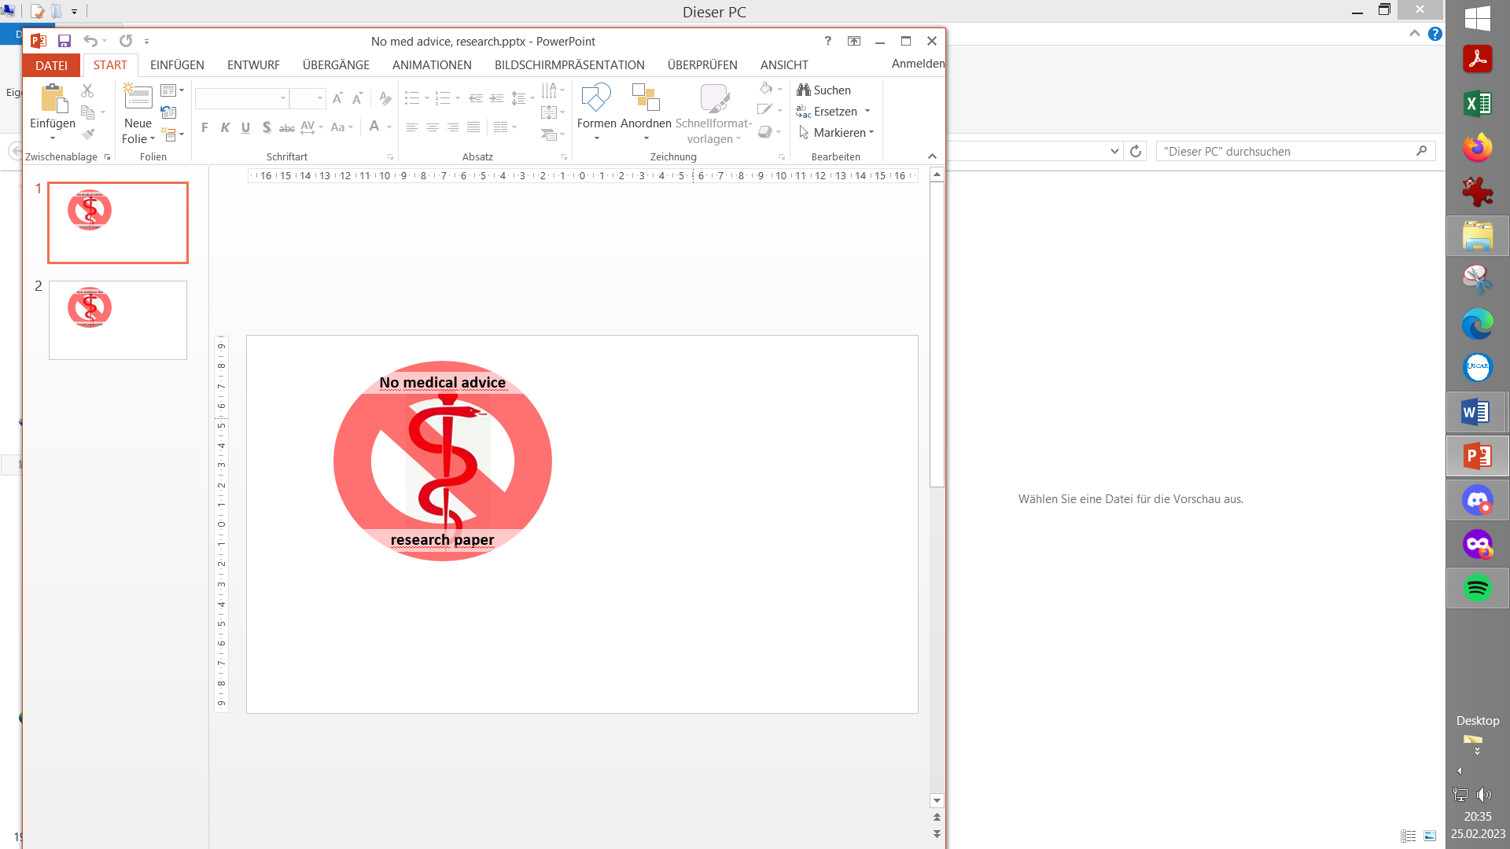
Exploring Full Closed Loop potential of-autoISF (=
Disclaimer – Important to read and understand
Authors are no medical professionals but T1 diabetics (or parents of a T1D child) who report their -limited - understanding and experience, in an effort to contribute to a growing body of knowledge, and to facilitate development of patient centered solutions.
Nothing in this site is medical advice, but meant to stimulate patient-driven self-responsible research, and is meant also to stimulate product developments by the medical industry. Anything you try to conclude for yourself you do on own risk. This is by no means a medical product but what is offered is a toolset for participating in development.
Never copy what others report to use, but investigate and adjust to your data. Neglecting safety instructions, and just using the “buttons” that are made available in a supposed “learning by doing” mode, would be very dangerous with the early development stage tools this research paper is about.
In case you choose to get deeper involved, run the system disconnected, parallel to your current glucose management, to learn its behavior before eventually considering (on own risk) to go any further. Please stay connected and share experiences, too.

Introduction

Full Closed Loop using Automations is represented in AAPS Master and in the related readthedocs since autumn 2023. (https://androidaps.readthedocs.io/en/latest/Usage/FullClosedLoop.html. ).
Pre-requisites and the principal function of a Full Closed Loop, without the user ever giving a bolus and without entering any carb info are explained, also in a couple of other languages, there (and also in our section 1.)

autoISF is being developed as a much more sophisticated alternative for FCL, aiming at higher %TIR performance and/or higher degree of daily „freedom“ than simpler approaches to FCL could provide.
However, this demands much higher degree of involvement by the user. Setting up your FCL is a very serious multi-week project, and it is important that you follow us through the material in the sequence of suggested steps.

Another world
Recently, also industry and academia are investigating into FCL, based on commercial systems. For instance: https://diabetesjournals.org/diabetes/article/74/Supplement_1/309-OR/159448/309-OR-Improvement-in-Day-and-Night-Glycemic.
Don’t be fooled by headlines. This is not comparable at all to what we are shooting for in the DIY FCL area. The linked study for instance just shows that a cohort with 7… 9 % HbA1c does about as “well” with the tested simple FCL, as with their HCL.
This is probably an important development and finding for a lot of people out there. But I find it important to distinguish that DIY FCLs are definitely playing in another league. Better performance. But more involvement required, notably upfront, to get it going.

Yet another world
FCL is probably not suited for “looping extremists” who do whatever it takes to limit incidence of bg values above 140 (or even 125) mg/dl, striving for HbA1c around or even under 5,0 %.
You very likely need to be in HCL for this - with very meticulous everyday attention to carb and FPU counting, as well as to pre-bolus timing and sizing.
Often a very strict low carb diet, and possibly a co-medication (see section 13.7), are involved as well. (This would improve FCL outcome, too).

autoISF FCL

With autoISF, and especially with the intention to use it for Full Closed Loop, you choose to take part in the development of a top-performing FCL. It is therefore important to observe the disclaimer given above, and the warnings given in the e-book sections, as well as the hints given by the developers in the respective manuals and readme files on their Github pages:

- For autoISF with AAPS, the main ones are https://github.com/ga-zelle/autoISF/ and https://github.com/T-o-b-i-a-s/AndroidAPS/tree/3.3.3-ai3.1.0 pick highest version
This e-book is valid for the current autoISF version.
However, most pictures are taken from AAPS3.2.0.4-ai3.0.1_no-version-check (which was in use in parallel to Master AAPS 3.3. because it took months to transform all autoISF code for AAPS 3.3).

Note that the current autoISF might not run yet with the latest AAPS.

In case you “must downgrade” your AAPS (temporarily) to include autoISF, please observe related advice in Discord.

Example (Jan.2026):

Is there any reason I would run into problems if I move from AAPS 3.4 to AAPS 3.3.3a +aisf3.1.0 since the base version of AAPS is an earlier edition? I exported my settings from the last master edition (before 3.4) before moving to 3.4.0.0-dev (L. 05.01.2026)

In the main channel I read that the base AAPS 3.4 database structure differs from the 3.3 version. So yes, needs export settings, de-install, re-install, re-import settings. Remember that the “States” function definitions are not included in the export and need to be retyped manually, including their use in other Automations. (ga-zelle — 05.01.2026)

- Note there is no comparable FCL solution for iOS Loop because their algorithm depends very much on carb inputs.

- However, the oref(1) algorithm (UAM+SMB as in AAPS) has been developed also for i-Phone based systems:
  - on the Trio platform https://discord.gg/Rr37aAzWz9, “TAI” (for Trio + autoISF) dev variant with autoISF see https://github.com/mountrcg/Trio#autoisf
  - on the iAPS platform, with autoISF ported into rapidly evolving early development branches of iAPS: https://github.com/mountrcg/iAPS / readme.md.
Note that setting up an autoISF FCL on an i-Phone platform may be especially hard: Trio and iAPS users are disadvantaged vs AAPS because 1) lack of some technical features (Automations, Emulator) 2) there is no e-book variant exactly for their system 3) many users did not go through the mandatory “education” via Objectives as in AAPS, and might not have a good “vanilla HCL” starting point (“blueprint for your FCL”, as I call it in section 4.1)
For Trio, the general documentation (readthedocs) is still in the making, and if you focus on your HCL as a first step, there will probably be more material on FCL by the time you are ready for the transition.

Unless you are ready to do a lot of reading and loop data analysis to get your FCL running, please stay away.
Trial and error won’t get you far: Yes; with 18 (!) additional parameters on bord, you always can “trick” your loop to get one situation (e.g. pizza) look pretty good. But to find settings that cover also other situations well (say, a salad with chicken) is not easy. It is possible, though, if you “build” your FCL following the suggestions, notably in sections 2 and 4).

Alternatives to autoISF FCL

If you currently can’t commit yourself, or lack an important pre-requisite, you might want to consider one of the following “easier” options:

- You could first try the Full Closed Loop in a simpler form with Automations (see AAPS readthedocs and section 13.1):
Depending on the quality of their HCL tuning they are starting from, their expectations for %TIR, and on rapid carb contents of their diet, an increasing number of people succeed in making a respectable start the first time they try using AAPS in that much simpler Full Closed Loop mode.
See also the first published medical study that included 16 patients using AAPS, who found, on average, comparable %TIR performance when using a basic Full Closed Loop mode: https://pubmed.ncbi.nlm.nih.gov/36826996/ - Also, watch out for what a 2025 on-going FCL study with AAPS in Australia and NZ will show. See CLOSE IT trial protocol in:
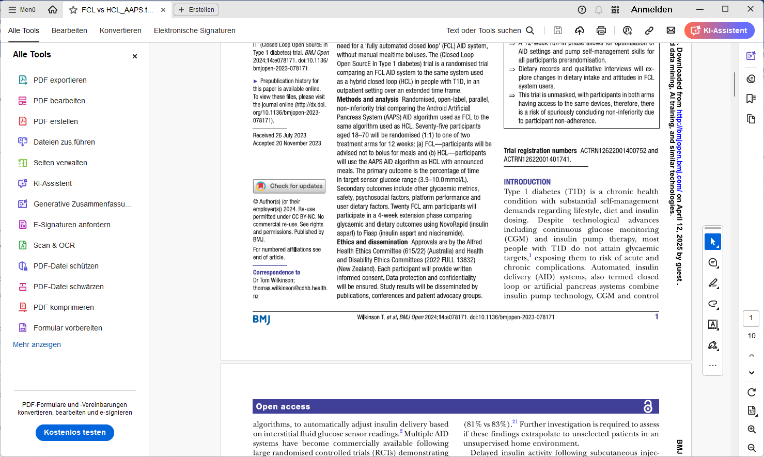

Note that Trio and iAPS lack Automations. (“Shortcuts” in Trio come with very limited options). This makes it more complicated if you try similar implementations, via so-called middleware,

- You could also opt for a Meal Announcement method, which is a significant step from HCL towards FCL, but still involves a pre-bolus.
  - For autoISF, this method is sketched in section 7.
  - Other early-DEV-variants of AAPS are mentioned in section 13.3, which also undergo permanent further development (Boost, AIMI, EatingNow, Tsunami).
  - AIMI was also ported into Trio as an option, see https://github.com/mountrcg/Trio#aimi-b30

Note that all these “Meal Announcement” methods are:
- less well described than the two FCL options ( …. and that might be OK for those who dislike reading a lot anyways, and rather proceed “hands-on” via trial and error)
- easier to set up, and give some of the benefits you may seek (notably, no carb counting).

